Landauer Rad Badge Dose Reports

# Purpose

The Joint Commission requires radiation badge dose reports to be posted, and signed by participants. This procedure describes how to retrieve dose reports, get initials, and keep initialed reports as records.

# Steps

1. Log into myLDR (myldr.landauer.com) using the username and password in the “Credentials & Computer Info” spreadsheet.
2. Go to **Reports** > **All Reports**.

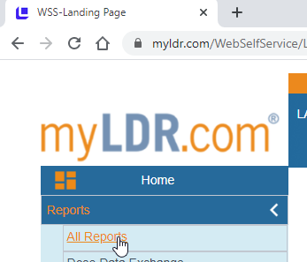

1. Use the filters to find your desired reports.

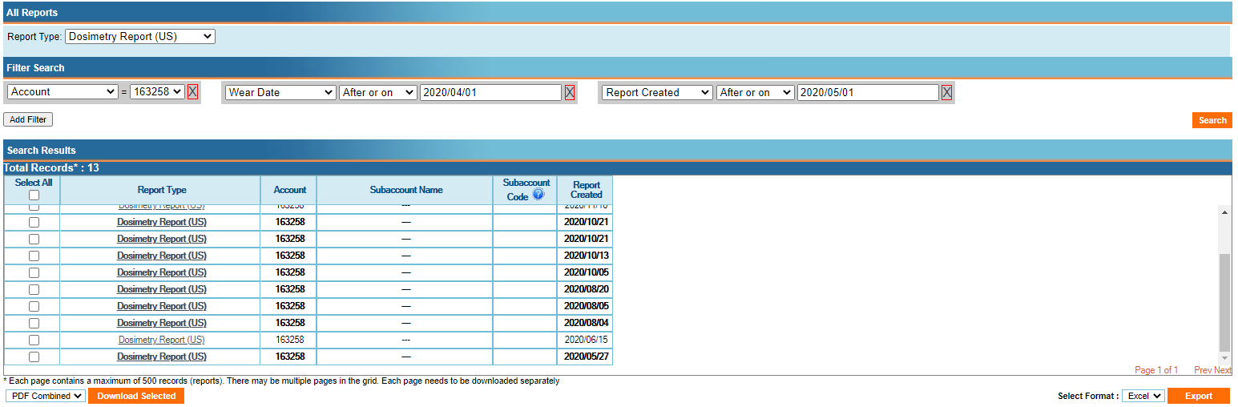

1. Download each desired report separately by clicking the report name, or download all selected reports as a **Single Zip File**.

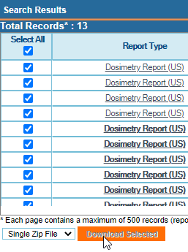

1. If you downloaded a zip file, extract all files.
2. Move files to **T:\Physics - T\PROCEDURES\Rad Safety\Rad Badges\Landauer Dose Reports*YYYY***. Rename each file. Examples:
   * Dose Report 6N Apr 2020
   * Dose Report Rad Once Apr-Jun 2020
3. Make a copy of each report and white out the birthday field.
4. Print the reports with and without the birthday field. Do not print the last page as it is just informational.
5. For nursing reports, write in the names of the nurses who used the spares.
6. Have the RSO sign the reports with the birthday field. Add the signed reports to the binder.
7. When you change out rad badges (see procedure “Replace 6N Nursing Radiation Badges”), display the reports without the birthday field, for participant review. Pin the rad onc report to the bulletin board at the E1 workstation. Pin the nursing report to the bulletin board near the rad badges in the 6N medication room.